**Institute of Information Technology**

**Jahangirnagar University**

Driver Drowsiness Detection Using Arduino

Microprocessor Project Report

Group No: 01

**Submitted by**

|  |  |
| --- | --- |
| **Name** | **Roll** |
| Md. Farabi Hasan | 1999 |
| Md. Shakil Hossain | 2023 |
| Mahbubur Rahman | 2024 |
| Nahidul Islam | 2028 |

**Submitted to:**

Dr. Rashed Mazumder

Assistant Professor

IIT-JU

Submission Date: 30-03-2023

**Contents**

**Introduction:** 3

**Background Study:** 3

**Objectives:** 3

**Scope of Study** 4

**Components Analysis** 4

**1.** **Arduino UNO** 4

**2. Eyeblink Sensor** 4

**3. RF Transceiver Module** 5

**4. HD12E & HD12D IC** 5

**5. Buzzer** 6

**6. 9V Battery** 6

**7. Wires** 6

**8.Breadboard** 7

**Methodology:** 7

**Circuit Diagram:** 8

**Transmitter Side:** 8

**Receiver Side:** 9

**Results:** 9

**Future Scope:** 9

**Limitation:** 10

**Conclusion:** 10

**References:** 10

# **Introduction:**

Drowsiness is a state of near sleep, where the person has a strong desire for sleep. It has two distinct meanings, referring both to the usual state preceding falling asleep and the chronic condition referring to being in that state independent of a daily rhythm [16]. Sleepiness can be dangerous when performing tasks that require constant concentration, such as driving a vehicle. When a person is sufficiently fatigue while driving, they will experience drowsiness and this leads to increase the factor of road accident.

The development of technologies for detecting or preventing drowsiness while driving is a major challenge in the field of accident avoidance system. Because of the hazard that drowsiness presents on the road, methods need to be developed for counteracting its affects. The aim of this project is to develop a simulation of drowsiness detection system. The focus will be placed on designing a system that will accurately monitor the open or closed state of the driver’s eyes. By monitoring the eyes, it is believed that the symptoms of driver's drowsiness can be detected in sufficiently early stage, to avoid a car accident.

# **Background Study:**

Each year, there is an increase in road accidents cases involving cars and heavy vehicles like buses, cars, motorcycles and trucks in Bangladesh. Drowsiness and fatigue condition is one of the prime factors contributing to road accidents. Driving in this condition may result terrible causes since it affects the driver’s judgment and concentration. Falling asleep on the wheel can be avoid if the drivers take efforts such as getting enough sleep before driving, taking caffeine or stop for a while to rest when the signs of fatigue and drowsiness appears.

However, in many cases, drivers refuse to take one of these steps even when they know that they are suffering from fatigue and will continue driving. Therefore, detecting drowsiness is important as one of the steps to prevent the road accidents. This project proposed that eyes blink rate detection is the obvious sign of fatigue and drowsiness.

# **Objectives:**

The project focuses on these objectives, which are:

* To suggest ways to detect fatigue and drowsiness while driving.
* To study on eyes of participants in the experiment of driving simulation conducted that can be used as an indicator of fatigue and drowsiness.
* To investigate the physical changes of fatigue and drowsiness.
* To develop a system that use eyes blink rate as a way to detect fatigue and drowsiness.

# **Scope of Study**

In this project, we focus on these following procedures:

* Basic concept of drowsiness detection system
* Familiarize with the signs of drowsiness
* Determine the drowsiness from these parameters

- Eye blink

- Area of the pupils detected at eyes

* Data collection and measurement.

# **Components Analysis**

## **Arduino UNO**

Here Arduino is introduced as microcontroller to

* 5 volt-VCC
* GND
* Digital Pin(2-13)
* Analog port(A4,A5,-SDA,SCL is used )

## **2. Eyeblink Sensor**

* VCC (Power)
* GND(Ground)
* DO(Digital Output)

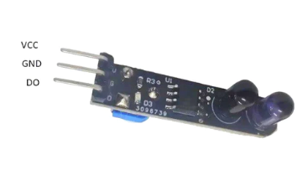

## **3. RF Transceiver Module**

The RF stands for Radio Frequency. The corresponding frequency range varies between 30 kHz & 300 GHz. Here we are using a **433 MHz RF Transceiver Module**. This **RF module** comprises a 433 MHz **RF Transmitter** and**RF Receiver**. The transmitter/receiver (Tx/Rx) pair operates at a frequency of **433 MHz.** A RF transmitter receives serial data and transmits it wirelessly through RF through its antenna. The transmitted data is received by an RF receiver operating at the same frequency as that of the transmitter.

The RF transmitter module uses **Amplitude Shift Keying** (ASK) and operates at 433MHz. The transmitter module takes serial data input and transmits that signal through RF. The transmitted signals are then received by the receiver module wirelessly.

* Ground: **Transmitter ground.**Connect to the ground plane
* Data: Serial data input pin
* VCC: Supply voltage; 5V
* ANT: Antenna output pin

The RF receiver module receives the data and sends it to the data OUTPUT pin. The output data can be decoded by the Microcontroller for further action.

* Ground: **Receiver ground.**Connect to the ground plane
* Data: Serial data output pin
* VCC: Supply voltage; 5V
* ANT: Antenna output pin

## **4. HD12E & HD12D IC**

12-bit Decoder IC to be used with HT12E

Decoded data has 4 Data bits and 8 Address bits (8+4=12-bits)

Commonly used for RF and IR wireless transmission

Operating Voltage 5V

Low stand by the current of 0.1uA at Vcc=5V

## **5. Buzzer**

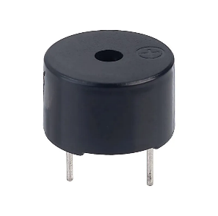

## **6. 9V Battery**

## **7. Wires**

Male to Male**,** Male to Female.

## **8.Breadboard**

A breadboard, solderless breadboard, or protoboard is a construction base used to build semi-permanent prototypes of electronic circuits. Unlike a perfboard or stripboard, breadboards do not require soldering or destruction of tracks and are hence reusable.

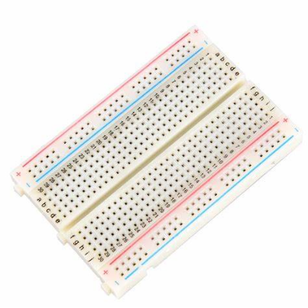

# **Methodology:**

The system works when the driver closes the eyes for around 3 seconds. There is an IR sensor in the system. It senses the eye blink of the driver and when the eye is closed for 3 seconds, the system gives an alarm. It is connected to the microcontroller, timer circuit, buzzer and the alarm. In the circuit there are capacitor, Resistance, diode and also regulator to control and purify the current flow, Capacitors and regulator are mainly fixed for adequate current flow to the components.

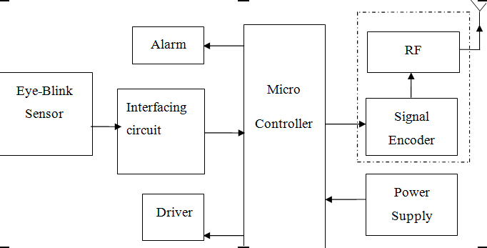

As shown in the image above, infrared sensors consist of two elements: infrared transmitter which acts as the source, and infrared receiver which acts as the receiver. Infrared sources include an IR LED and Infrared detectors include photodiodes. The energy emitted by the infrared source is reflected by an object and falls back on the infrared detector. When the light emitted by the IR LED falls on the receiver, the resistance of the photodiode falls down significantly. This photoreceiver is connected with a potentiometer to form a voltage divider circuit, which gives a variable analog output when blinking activity is detected.

When the incident radiation is more on the photodiode, the voltage drop across the series resistor/Potentiometer will be high. In the Comparator IC which is nothing but an **Operational Amplifiers,** or **Op-amps**, both the reference analog voltage and the actual output voltages are compared. If the voltage across the resistor series to photodiode is greater than that of the reference voltage, the output of the comparator is high, else Low. As the output of the comparator is connected to an LED, it glows when the sensor detects some activity such as eye blinking. The threshold voltage can be adjusted by adjusting the potentiometer depending on the environmental conditions.

# **Circuit Diagram:**

## **Transmitter Side:**

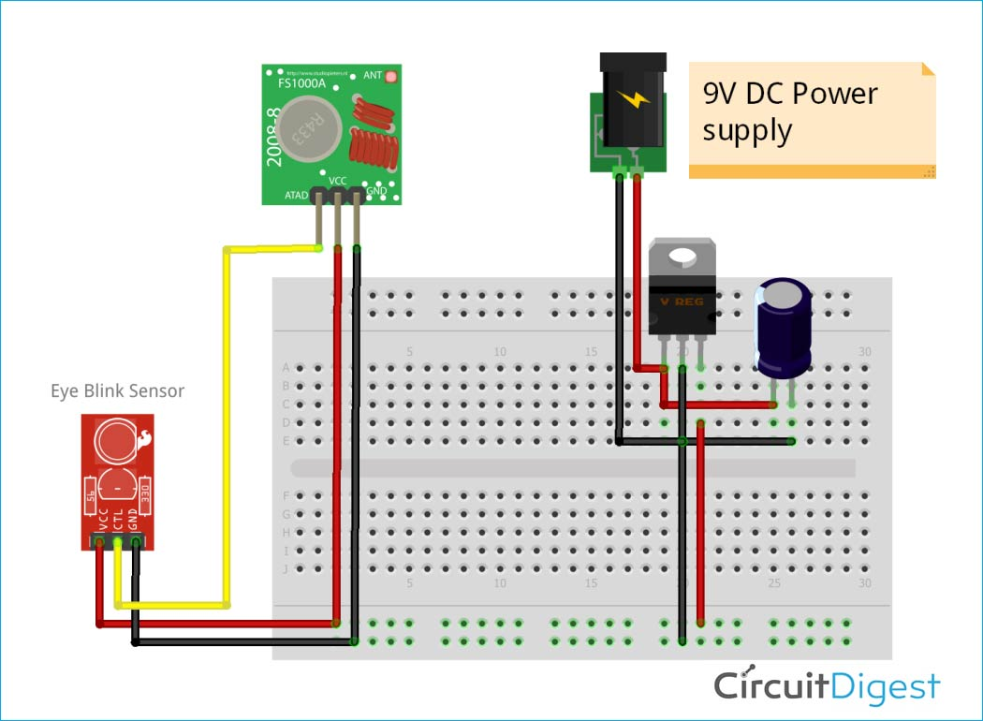

## **Receiver Side:**

# **Results:**

The anti drowsiness system was successfully designed and implemented. It was tested and it was able to detect and alert the user when the eye is closed more than 3 seconds. The alarm was loud and effective in capturing the driver's attention, which helped in eradicating drowsiness and fatigue.

# **Future Scope:**

* The model can be improved incrementally by using other parameters like yawning, state of the car, etc. If all these parameters are used it can improve the accuracy by a lot.

* We plan to further work on the project by adding a sensor to track the heart rate in order to prevent accidents caused due to sudden heart attacks to drivers.
* Same model and techniques can be used for various other uses like Netflix and other streaming services can detect when the user is asleep and stop the video accordingly. It can also be used in application that prevents user from sleeping.

# **Limitation:**

* The driver needs to wear the sunglass during driving.
* Light poles may be recognized as eye candidates due to the shape and size on screen.

# **Conclusion:**

The purpose of the drowsiness detection system is to aid in the prevention of accidents passenger and commercial vehicles. The system will detect the early symptoms of drowsiness before the driver has fully lost all attentiveness and warn the driver that they are no longer capable of operating the vehicle safely. The project also showcase benefits of using Arduino based projects for solving real world problem like this. Overall, the motivation behind the project is to improve road safety and promote safe driving habits, ultimately reducing the number of accidents and fatalities.

# **References:**

[1] Robert D. Ogilvie and John R. Harsh, *Sleep Onset*. New York:   
 American Psychological Association, 1994.

[2] Mitsuaki Yamamoto, *Night—day—night Sleep—Wakefulness Monitoring   
 by Ambulatory Integrated Circuit Memories*. Boston: Psychiatry and   
 Clinical Neurosciences, 1999.

[3] Singh, Sarbjit and Papanikolopoulos, N.P. “Monitoring Driver Fatigue   
 Using Facial Analysis Techniques”, IEEE Intelligent Transport System   
 Proceedings pp314-318, 1999.

[4] *Perez, Claudio A. et al. “Face and Eye Tracking Algorithm Based on   
 Digital Image Processing”, IEEE System, Man and Cybernetics 2001   
 Conference,pp 1178-1188, vol.2 (2007)*

[5] *F. D. Torre, C. J.G. Rubio, E. Martinez, “Subspace Eye Tracking for Driver  
 Warning,” in Proceedings of the IEEE, Vol. 8, No. 3, 2008, pp 329-332.*